# Fix/setup file windows on your home computer

Microsoft, in its infinite wisdom, ships Windows with a lot of really important stuff hidden. You **WILL** want to correct this unfortunate oversight.

In your file window, look for a menu with "Tools" on it. If you don't see the menu, press alt and let go, to make the menu appear. Then click Tools, Folder options...

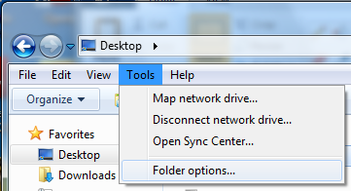

...and you will see this. Make your dialogue box look like this.

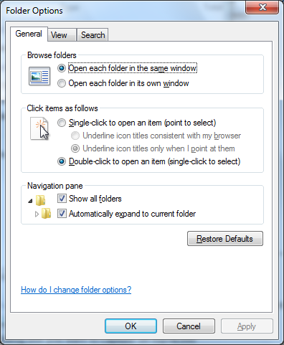

Click apply, and then click the View Tab and make it look like this. Most important are check "Always show menus" and uncheck "Hide extensions for known file types".

s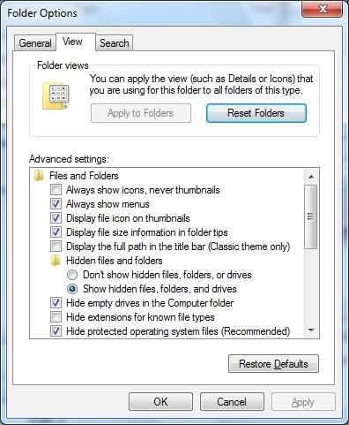

And scroll down for this...

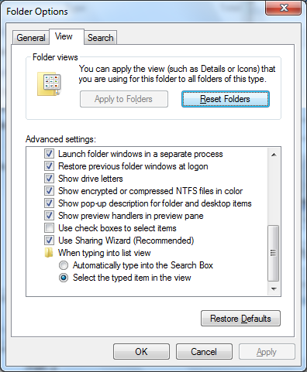

And hit apply and/or OK.

Then fix the window panes. Click on Organize, Layout, and make sure the items you have enabled/checked/selected things like Details pane and Navigation pane, and probably Menu bar. This will vary depending on your OS.

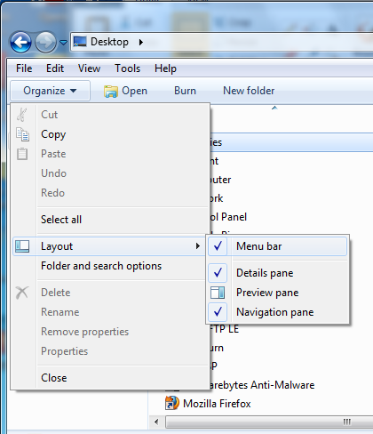

Do NOT turn on the Preview Pane. It sounds interesting, but it will cause "file in use" errors.